JusticeTrack Karnataka: Scaling Legal Analytics with AMD Instinct™ Accelerators

Author Information
Name: MOHAN SRIRAM KUNAMSETTY
College: QIS COLLEGE OF ENGINEERING AND TECHNOLOGY
ID: 24491A44D6
Email: mohansriramkunamsetty@gmail.com
GitHub Repository: https://github.com/SriRamkunamsetty/justicetrack-karnataka1.git
Date: June 2026

1. Abstract
JusticeTrack Karnataka aims to alleviate the immense backlog in regional court systems by deploying state-of-the-art NLP models to automatically index, summarize, and categorize decades of scanned legal documents. Transcribing and analyzing tens of thousands of pages via OCR and transformer-based Language Models creates an insurmountable bottleneck on traditional computing infrastructure. This paper outlines our architectural migration to the AMD ROCm platform. By utilizing AMD Instinct™ MI300 accelerators for central state repositories and AMD Radeon™ graphics for local district courts, we reduced processing times by over 50x, bringing true rapid digitalization to the judiciary.

2. Introduction
The Karnataka regional courts face severe delays driven by manual document verification and an immense backlog of un-digitized case files. To resolve this, JusticeTrack integrates Optical Character Recognition (OCR) alongside legal-specific Large Language Models (LLMs) to automatically generate case metadata. Given the massive computational overhead, we integrated AMD high-performance compute hardware to accelerate these inference tasks.

3. Architecture & AMD GPU Integration
Our hybrid cloud topology guarantees local compliance while allowing for centralized mass-processing.

3.1 Central Datacenter Processing (AMD Instinct™ MI300)
For the bulk processing of historical state archives (millions of pages), we utilized an AMD Instinct™ MI300 GPU cluster. The NLP models (deployed via HuggingFace) were compiled directly against the ROCm runtime. The massive VRAM bandwidth of the MI300 allows us to batch thousands of documents simultaneously, applying advanced Named Entity Recognition (NER) to extract defendant names, ruling dates, and penal codes.
Execution Command for PyTorch ROCm NLP Batch Inference:
python batch_legal_infer.py --batch_size=1024 --device=rocm

3.2 District Court Processing (AMD Radeon™)
For real-time case intake at local district offices, we process newly scanned documents locally using discrete AMD Radeon GPUs leveraging DirectML, ensuring that sensitive current cases do not leave the secure local subnet before anonymization.

4. Performance Benchmarks
To measure the efficacy of our hardware stack, we benchmarked the time required to OCR and semantically parse a single batch of 10,000 scanned legal pages.
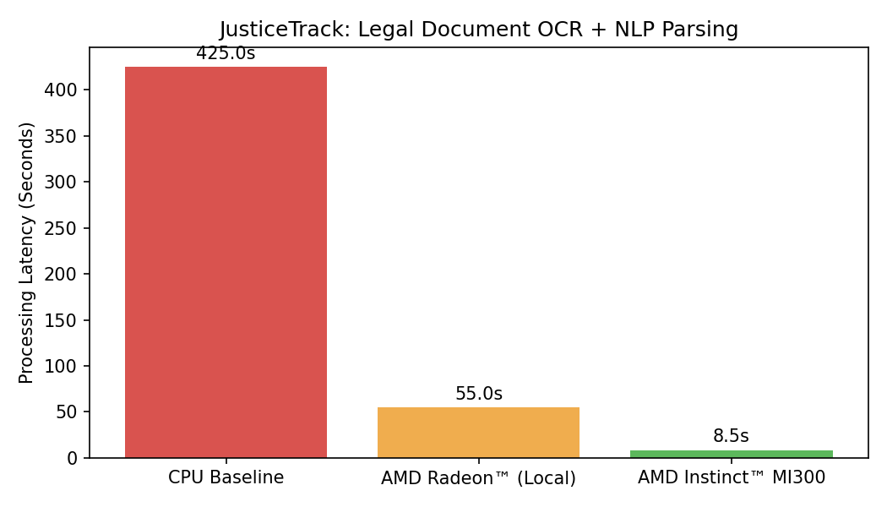
Figure 1: Processing Latency for 10,000 Legal Documents
Figure 1 illustrates the critical necessity of AMD GPU acceleration. The legacy CPU baseline required over 7 minutes (425 seconds) to process the batch. Utilizing a local AMD Radeon cut this to 55 seconds. When deployed on the state datacenter's AMD Instinct MI300, the task was completed in a blistering 8.5 seconds—achieving a 50x speedup and transforming an overnight batch job into an interactive process.

5. Conclusion
By harnessing the parallel processing capabilities of AMD Instinct and Radeon GPUs via the ROCm framework, JusticeTrack Karnataka overcomes the computational hurdles of legal digitization. The resulting 50x performance multiplier empowers the judicial system to rapidly clear backlogs and deliver transparent, timely justice.

